TRANSMISSION MEDIA
- Definition: Medium by which data travels from sender to receiver.
- It is classified in following category.
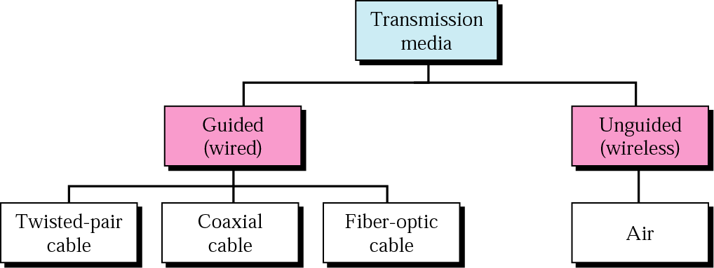
GUIDED MEDIA
Definition: Transmission medium in which data/signal is guided by the cable or Wire.
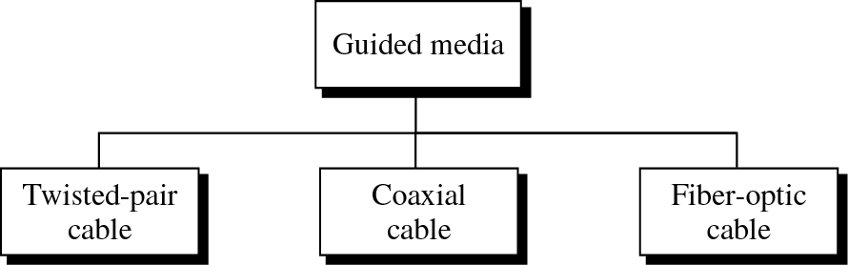
TWISTED PAIR CABLE
- A type of cable that consists of two independently insulated wires twisted around one another.
- The use of two wires twisted together helps to reduce crosstalk and electromagnetic induction. A pair of cables twisted around each other forms a twisted pair cable.
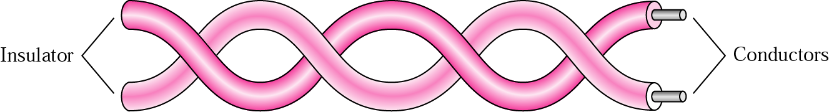
- Consist two conductors, each with its own plastic insulation.
- One wire used to carry signal, other is used as ground reference.
- A pair of wires forms a circuit that can transmit data.
- Why Twisted? Justify: The pairs are twisted to provide protection against crosstalk, the noise generated by adjacent pairs and EMI ( Electro Magnetic Interference ).
- When electrical current flows through a wire, it creates a small, circular magnetic field around the wire.
- When two wires in an electrical circuit are placed close together, their magnetic fields are the exact opposite of each other. Thus, the two magnetic fields cancel each other out.
- They also cancel out any outside magnetic fields.
- Twisting the wires can enhance this cancellation effect.
- Used in Telephone system and Local Area Network
- There are 2 types of twisted pair cable
    - Unshielded Twisted Pair
    - Shielded Twisted Pair
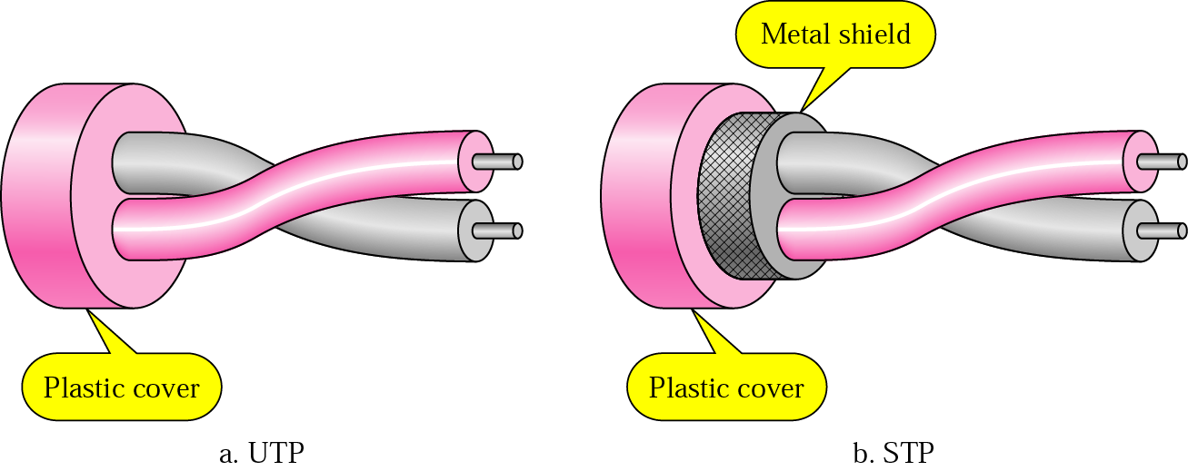
Advantages
- Being the oldest method of data transmission, trained manpower to repair and service this media of communications are easily available.
- In a telephone system, signals can travel several kilometers without amplification when twisted pair wires are used.
- Used for both analog and digital data transmission.
- Least expensive media for transmission for short distances.
Disadvantages
- Easily pick up noise signals which results in higher error rates .
- Being thin in size, it is likely to break easily.
- Support Less Speed
- UTP Cable
- This is the most commonly used twisted pair type and the most widely used on local networks.
- UTP cable is a medium that is composed of pairs of wires (see Figure). UTP cable is used in a variety of networks.
- Each of the eight individual copper wires in UTP cable is covered by an insulating material. In addition, the wires in each pair are twisted around each other.
- No metallic shield around wires.
- Each pair uniquely color coded when it is packaged in multiple pairs.
- So it is Unprotected against electrical interference.
- Due to Low cost extensively used in telephone system and LAN.
- Maximum segment length is 100 meters.
- Connector : RJ45 (Registered Jack). The RJ-45 is an eight-wire connector used commonly to connect computers onto a local-area network (LAN), especially Ethernets.
- EIA ( Electronic Industries Association) has developed standard to classify UTP.
- Classification are determined by cable quality.
- Each category is suitable for specific use.
Category | Bandwidth | Data Rate | Digital/Analog | Use
1 | very low | < 100 kbps | Analog | Telephone
2 | < 2 MHz | 2 Mbps | Analog/digital | T-1 lines
3 | 16 MHz | 10 Mbps | Digital | LANs
4 | 20 MHz | 20 Mbps | Digital | LANs
5 | 100 MHz | 100 Mbps | Digital | LANs
6 (draft) | 200 MHz | 200 Mbps | Digital | LANs
7 (draft) | 600 MHz | 600 Mbps | Digital | LANs
- Shielded Twisted Pair
- Produced by IBM
- Shielded twisted-pair (STP) cable combines the techniques of shielding, cancellation, and wire twisting. Each pair of wires is wrapped in a metallic foil (see figure).
- The four pairs of wires then are wrapped in an overall metallic braid or foil, usually.
- As specified for use in Ethernet network installations, STP reduces electrical noise both within the cable and from outside the cable.
- STP usually is installed with STP data connector, which is created especially for the STP cable. However, STP cabling also can use the same RJ connectors that UTP uses.
- Although STP prevents interference better than UTP, it is more expensive and difficult to install.
- In addition, the metallic shielding must be grounded at both ends. If it is improperly grounded, the shield acts like an antenna and picks up unwanted signals. Because of its cost and difficulty with termination, STP is rarely used in Ethernet networks
- Features :
- Speed and throughput—10 to 100 Mbps
- Average cost per node—Moderately expensive
- Maximum cable length—100 m (short)

Advantage of STP over UTP
- STP is less susceptible to noise as compared to UTP and therefore reduces the cross talk and interference.

Disadvantages of STP
- It must be properly grounded.
- It is more expensive than UTP.
- It is difficult to terminate.
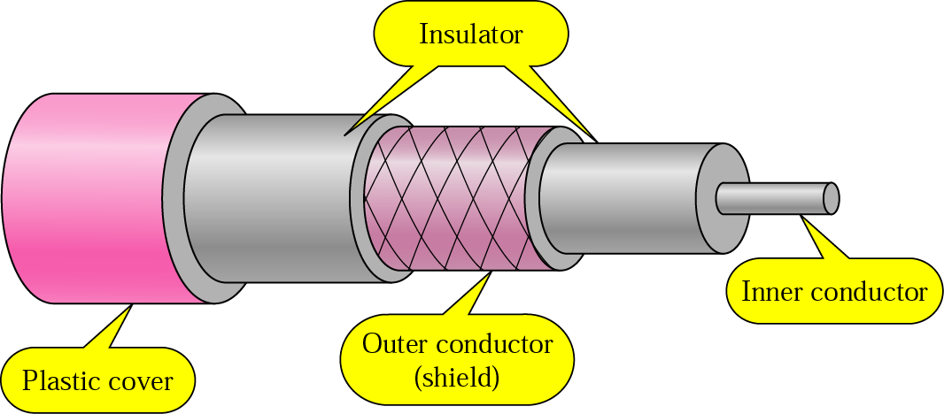
CO-AXIAL CABLE
- A coaxial cable is one that consists of two conductors that share a common axis.
- Has central core conductor of solid enclosed in an insulating sheath, which is encase in outer conductor of metal foil.
- Outer metallic wrapping is used as a shield against noise and as the second conductor which completes the circuit. The outer conductor is also encased in an insulating sheath. The outermost part is the plastic cover which protects the whole cable.
- Outer conductor is a shield against noise and Whole cable is protected by plastic cover.
- Carries signal of higher frequency range than Twisted Pair.
- A cable that is used in video, communications, and audio.
- This media is used in base band and broadband transmission.
- Two types of coaxial cables are widely used:
- 50 ohm cable: Used for digital Transmission
- 75 ohm cable: Used for analog transmission.
- They are often installed either in a device to device daisy chain (Ethernet) or a star (ARC net).
- Categorized by their Radio Government (RG) ratings.
- RG number denote unique set of physical specification.
- Each cable adapted for specific function.
Category | Use
RG-59 | Cable TV
RG-58 | Thin Ethernet
RG-11 | Thick Ethernet
- Connector: BNC Connector ( Bayone Neill Concelman)
- Application of Co-axial Cable:
- Cable TV
- Traditional Ethernet LAN
- Types of cable
- Thin co-axial cable
- Thick co-axial cable
  - Thin co-axial cable
- Thin coaxial cable is also referred to as thinnet.
- 10Base2 refers to the specifications for thin coaxial cable carrying Ethernet signals.
- The 2 refers to the approximate maximum segment length being 200 meters. In actual fact the maximum segment length is 185 meters.
- Thin coaxial cable is popular in school networks, especially linear bus networks.
- “Base” means digital transmission.
  - Thick co-axial cable
- Thick coaxial cable is also referred to as thicknet.
- 10Base5 refers to the specifications for thick coaxial cable carrying Ethernet signals.
- The 5 refers to the maximum segment length being 500 meters.
- Thick coaxial cable has an extra protective plastic cover that helps keep moisture away from the center conductor.
- This makes thick coaxial a great choice when running longer lengths in a linear bus network. One disadvantage of thick coaxial is that it does not bend easily and is difficult to install.
Advantages
- Better shield against EMI than twisted pair cable, so it can span longer distance at higher data bits per second (bps).
- It can be used for both analog and digital data transmissions.
- It is inexpensive as compared to twisted pair wires and UTP cables but easy to handle.
- Bandwidth is high
- Used in long distance telephone lines.
- Transmits digital signals at a very high rate of 10Mbps.
- Much higher noise immunity
- Data transmission without distortion.
Disadvantages
- More expensive to install compare to twisted pair cable.
- The thicker the cable, the more difficult to work with.
- Single cable failure can fail the entire network.
FIBER OPTIC
- An optical fiber is a flexible, transparent fiber made of extruded glass (silica) or plastic, slightly thicker than a human hair.
- It can function as a waveguide, or “light pipe”, to transmit light between the two ends of the fiber.
- Fiber means Glass Or Plastics and Optics means Light.
- Fiber Optics = Light guided in Glass.
- Electrical signals are converted into light signals
- A phenomenon called as total internal reflection is used for transmission
- LED or laser is used to transmit signal
- Because a fiber-optic cable is light-based, data can be sent through it at the speed of light.
- Using a laser transmitter that encodes frequency signals into pulses of light, ones and zeros are sent through the cable.
- The receiving end of the transmission translates the light signals back into data which can be read by a computer.
Component of Fiber Optic
- Fiber optics cable is divided into five parts.
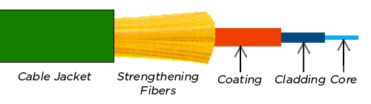
- Core
- Cladding
- Coating
- Strengthening Fiber
- Cable Jacket

CORE
- This is the physical medium that transports optical data signals from an attached light source to a receiving device.
- The core is a single continuous strand of glass or plastic that’s measured in microns (µ) by the size of its outer diameter.
- The larger the core, the more light the cable can carry.
- All fibre optic cable is sized according to its core’s outer diameter.
- The three multimode sizes most commonly available are 50, 62.5, and 100 microns.
- Single-mode cores are generally less than 9 microns.
CLADDING
- This is the thin layer that surrounds the fibre core and serves as a boundary that contains the light waves and causes the refraction, enabling data to travel throughout the length of the fibre segment.
- Outer optical material surrounding the core that reflects the light back into the core.
COATING
- This is a layer of plastic that surrounds the core and cladding to reinforce and protect the fibre core from damage and moisture.
- Coatings are measured in microns and can range from 250 to 900 microns.
FIBRES
- These components help protect the core against crushing forces and excessive tension during installation.
CABLE JACKET
- This is the outer layer of any cable. Most fibre optic cables have an orange jacket, although some types can have black or yellow jackets.
Advantages
- High Bandwidth: Fibre provides greater bandwidth than copper, so it's ideal for data-intensive multimedia applications.
- Greater Distances: Very little signal loss occurs during transmission so data travels greater distances
- Immunity and reliability: The fibre is made of glass, which is an insulator, making it immune to electromagnetic interference and radio-frequency interference (EMI/RFI),
- Material cost and theft prevention: Conventional cable systems use large amounts of copper. In some places, this copper is a target for theft due to its value on the scrap market.
Que: When choosing the transmission media, what are the factors to be considered?
- Transmission Rate
- Distances
- Cost and Ease of Installation
- Resistance to Environmental Conditions

